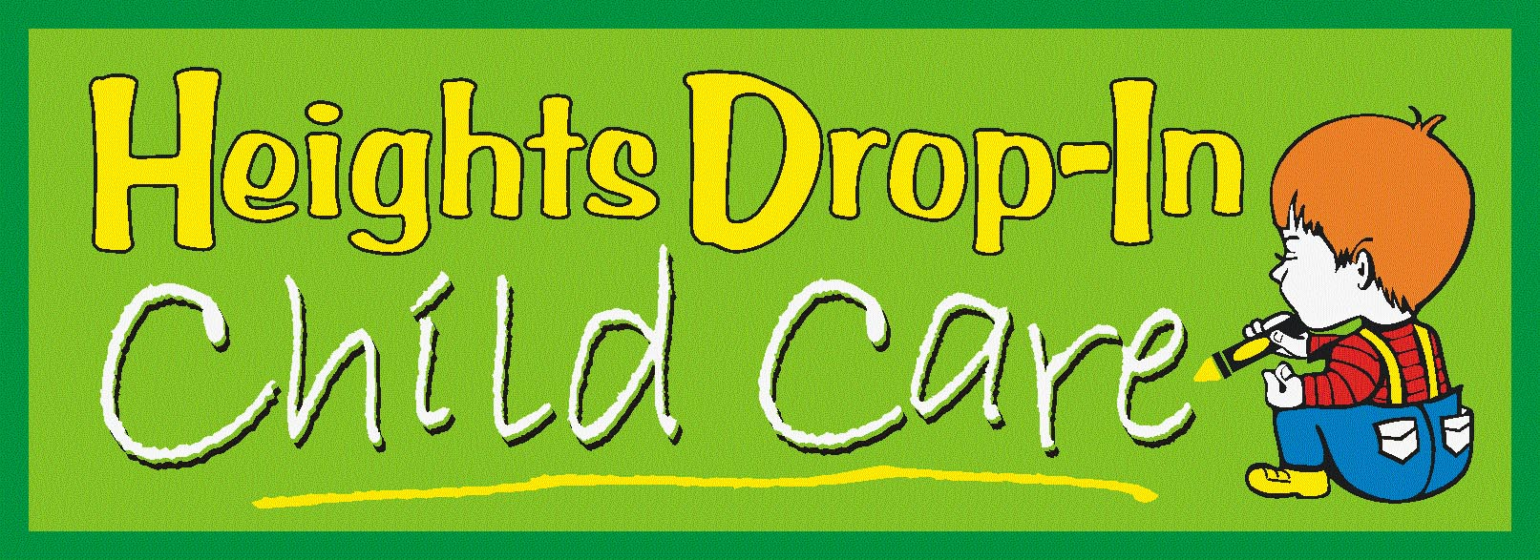

Terms & Conditions

Services

Heights Drop-In Child Care Centers “HD3C” agree to provide services to all customers that agree and adhere to the following terms and conditions outlined by these companies.

In order to protect our customers, the company, and maintain the terms and conditions of this agreement, HD3C reserves the right to refuse services to anyone for any reason at management’s sole discretion.

In addition, children will only be released to individuals authorized on the New Customer Sheet and on the Sign-In Sheet. For the protection of the children we require all information to be current. Furthermore, it is the sole responsibility of the customer to update any information on your contact sheet including authorized pick-up people, emergency contact numbers, parents or guardian phone numbers, etc…
Shot records for each child are required at the first visit.

Child Care Rates

Hourly Charges
Ages 18 months to 11 years (1 hour minimum) $4.50/HR

Additional Charges

Breakfast FREE
Lunch $3.50
Dinner $3.50
Diapers $0.75
Extra Clothes (refund on return) $5.00
Late Charge (per minute – per child) $1.00
* Snacks provided at no additional charge
Meal & Snack Times

Breakfast 8:00 am
Morning Snack 10:00 am
Lunch 11:30 am
Afternoon Snack 2:30 pm
Dinner 6:00 pm
Evening Snack 8:00 pm
* Quiet Time 1:00 – 2:30 pm

Pre-Pay Child Vouchers

Voucher 1 ($110 of Childcare) $100.00
Voucher 2 ($225 of Childcare) $200.00
Voucher 3 ($350 of Childcare) $300.00
Voucher 4 ………...($465 of Childcare)……….. $400.00
Voucher 5 ………...($585 of Childcare)……….. $500.00
Voucher 6 ($700 of Childcare) $600.00

Daily Discounts

Full Day Discount (8 or more hours) 10%
Multi Child Discount (2 Kids) 5%
Multi Child Discount (3 Kids) 10%
Multi Child Discount (4+ Kids) 15%

* Daily Discounts may not be used with Voucher

Payment of Services

Customer must pay the full amount due at the time of child pick-up.

HD3C accepts payment for services in the form of cash, or credit card. HD3C does not accept checks.
Late charges apply to customers that pick-up after the posted closing times. For every minute late there is a $1.00 per minute/per child late fee added to your total charges for the day.

Child Behavior Standards & Discipline (Children 18 months – 11 years)

Following is a list of rules that HD3C enforces for all children that use its facilities.

- Children must stay within the gated area.
- Children must keep all hands, feet, and other objects to themselves.
- Children will respect and listen to the teachers on duty at all times.

These rules are in place to protect all children and create a safe and healthy environment for everyone. If HD3C has any issues or problems with any children in regards to these basic rules they will be subjected to the following disciplinary schedule.

Step 1 - Verbal Warnings (2 or 3 Warnings)
Attempt to correct offence by talking with the child about what is acceptable and unacceptable behavior at daycare.

Step 2 - Timeout Sessions (2 or 3 Sessions)
Attempt to correct offence by sitting child in timeout for an appropriate amount of time for child’s age and infraction.

Step 3 - Telephone Call to Parents
Attempt to correct offence by having child speak to a parent or guardian on telephone about child’s behavior.

Step 4 - Child Sent Home
If steps 1 – 3 are not effective in correcting behavior, then the child will be sent home. Additionally, further actions will be discussed with parents or guardians by a representative of HD3C. After the third time a child is sent home he or she will no longer be allowed to use HD3C’s services.

All discipline will be appropriate to the child’s age and developmental level. Discipline will focus on teaching appropriate behaviors and self-management. HD3C engages only is positive disciplinary actions including redirection, direct praise, indirect praise, role modeling, and time-outs.

Sick Child Policy

It is often difficult to tell when your child is not well enough to go to daycare. If your children are not well enough to participate in their normal daily routine, then they should not be brought to daycare. If your child is not allowed to go to school or other daycare facilities because they are sick, please do not try to bring them here as a last resort. Unfortunately, we do not have the staff or the facilities to take care of sick children.

If your child develops symptoms of illness while at HD3C, we will contact the parent or guardian and request that they be picked up as soon as possible.

Signs to Observe:

- ACTIVITY LEVEL
- SKIN COLOR
- SPOTS OR RASHES
- SORES
- SEVER COUGH OR SNEEZING
- DISCHARGE FROM NOSE OR EYES
- BREATHING DIFFICULTIES
- CHANGE IN MOOD
- CHANGE IN BEHAVIOR
- FEVER (24 HR FEVER FREE)
- VOMITING (24 HR VOMIT FREE)
- DIARRHEA (24 HR DIARRHEA FREE)

- Facility Policy

Heights Drop-In Child Care Center is not responsible for lost or stolen items. Items left behind will be placed in the lost and found at the end of each day. If items are not claimed within 60 days, they will be donated to charity.

To ensure the safety of all children, please make sure that all small items are left outside the gate; including all personal toys, coins, suckers, candy, gum and all other small objects.

